


Thesis Proposal
CONSULTATION SHEET

Project Title:  Addressing Typographic Hallucination in Generative AI Images: An Open-Set Metric Learning Approach to Font Style Recognition | Week # 2 | Group Members:  - Janritch D. Diputado  - Matt Erron G. Cabarrubias
Date:
June 30, 2026
July 1, 2026
Progress Report (based on the adviser’s previous comments/suggestions) by Students
1st meeting (June 30):
- Gathered more literatures to support thesis
- Found an existing system similar to our thesis scope
2nd meeting (July 1):
- Working on Chapters 2, 3, and Bibliography
Recommendations by Adviser
1st meeting (June 30):
- Find the gaps of the existing system and either optimize or improve on the system.
2nd meeting (July 1):
- Did not meet for second meeting
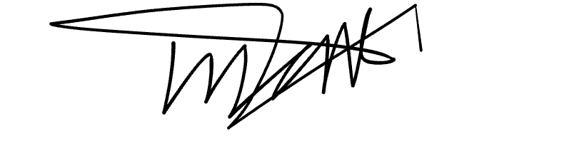

Prepared by:
Janritch D. Diputado | Matt Erron G. Cabarrubias
Noted by:
CHRISTINE D. BANDALAN, MEng
Thesis Adviser

